In this document is showed how to use TileMill to create a base layer with real information about Switzerland. The first steps about how to create the project and start the map are the same as in the initial example.

It will be useful to take a look to TileMill CartoCSS reference. It is accessible by clicking the {} button, and there is [an online CartoCSS reference by MapBox](http://mapbox.com/carto/).

Once we have the map, we add the layers. As it is explained in the initial example, we click in the “Add Layer” button and we select the datasource path. We could change the id that appears by default and we can add a class, to write the css.

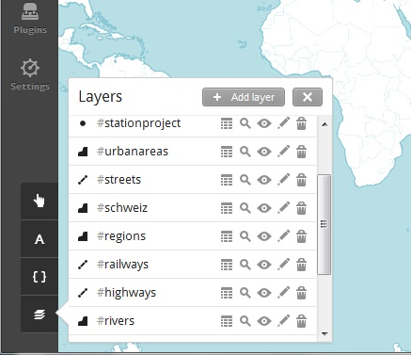

There are different kinds of layers, which will we treated differently when we write the necessary css. Once we have added the layers, we can know the type of every layer. In this case, #stationproject will be an example of point; #urbanareas will be an example of polygon; and #streets will be an example of line.

* linestring: the only css code we need is the color in which we want to show it
* ::outline { line-color: #800080; }
* polygon: the css code we need is the color in which we want to show the border and the inside
* ::outline { line-color: #00CED1; }
* ::fill { polygon-fill: #00CED1; }
* point: the css code we need is the color in which we want to show
* marker-fill: #FFFF00;
* point: and we can change the size of the point
* marker-width: 3;

When we have finished writing the css code for very layer, we could add a legend to show some extra information about a layer. For example, to know in which color we are showing each information.

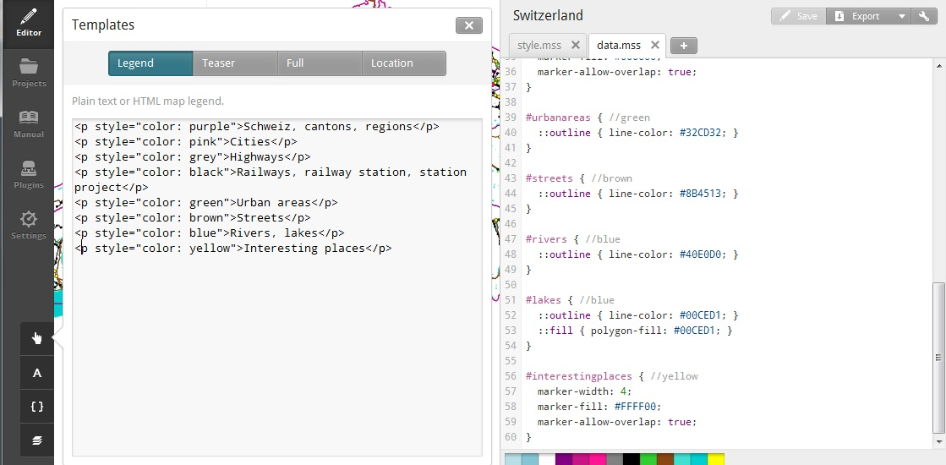

The final step will be to export as mbtiles. Remember not to choose to many zoom levels or the size of the map will be too big. You can also restrict the part of the world that is going to be shown to Switzerland and a little bit around it.